**PROXY TRAINING MANUAL**

Contents

THE WORLD OF PROXY SOLICITATION…………………………………………………………………………………………………………1

ROLE OF THE AGENT 4

PHONE ETIQUITTE 4

REGISTRATION TYPES 6

QUALITY ASSURANCE 10

THE SCRIPT 11

ALLIANCE DIALING SYSTEM 12

Logging into the Alliance Dialing System 12

Clocking in and out 21

THE WORLD OF PROXY SOLICITATION

**Public Companies**

A private company becomes public when it has issued securities through an **initial public offering (IPO)** and is traded on at least one **stock exchange** or in the **over-the-counter (OTC)** market. Although a small percentage of shares may be initially "floated" to the public, the act of becoming a public company allows the market to determine the value of the entire company through daily **trading**. Public companies have inherent advantages over private companies, including the ability to sell future **equity** stakes and increased access to the **debt** markets. However, with these advantages comes increased regulatory scrutiny and less control for majority owners and company founders.

Once a company “goes public”, it has to answer to its shareholders. For example, certain corporate structure changes and amendments must be brought up for shareholder **vote** at **annual meetings**. Public companies must meet stringent reporting requirements set out by the **Securities and Exchange Commission (SEC)**, including the public disclosure of financial statements and annual “10-K” reports discussing the state of the company. Each stock exchange also has specific financial and reporting guidelines that govern whether a stock is allowed to be listed for trading.

**Corporate Governance**

This is a system of rules, practices and processes by which a company is directed and controlled. It essentially involves **balancing the interests** of the many stakeholders in a company (shareholders, management, customers, suppliers, financiers, government and the community). Since corporate governance also provides the **framework for attaining a company's objectives**, it encompasses practically every sphere of management, from action plans and internal controls to performance measurement and corporate disclosure.

Corporate governance became a pressing issue following the 2002 introduction of the **Sarbanes-Oxley Act**, which was ushered in to restore public confidence in companies and markets after accounting fraud bankrupted high-profile companies such as Enron and WorldCom. Most companies, led by an elected **Board of Directors**, strive to have a high level of corporate governance. These days, it is not enough for a company to merely be profitable; it also needs to demonstrate **good corporate citizenship** through environmental awareness, ethical behavior and sound corporate governance practices.

**Shareholders**

Any person, company or other institution that owns at least one share of a company’s stock is a shareholder (or stockholder). As owners (i.e., having “equity” in the company), they have the potential to share in the profit or loss of the company. A list of active owners of a company's shares is updated on an ongoing basis. This **shareholder register** requires that every **registered owner** be recorded, including name, address and number of shares held. A person who has the benefits of ownership but with title in another name is called a **beneficial owner**, and may include any individual or group that, either directly or indirectly, has the power to vote. For example, when shares of a **mutual fund** are held by a **custodian bank** or when **securities** are held by a **broker** in ‘street name’, the true owner is the beneficial owner, even though, for safety and convenience, the bank or broker holds title. The beneficial owner may give authorization for their name to be released to the company for the purposes of direct solicitation; these are **non-objecting beneficial owners (NOBOs)**, and can be directly contacted by Alliance for voting purposes. **Objecting beneficial owners (OBOs)** do not give up their right of privacy and can only be contacted by their custodian, not by the company.

**Voting Rights**

Under U.S. corporate law, companies are required to hold **annual meetings**, offering shareholders the right to vote on certain matters (usually one vote per share). Such matters always include the election of a **board of directors**. In addition, matters of **corporate governance** that could affect the rights of individual shareholders are presented for shareholder vote; such as recapitalizations, restructurings (such as reincorporation in a different state) and **mergers** and **acquisitions** and other types of **corporate actions** where shareholder interests could be **diluted**. Such special matters can also be brought forth at **special meetings**, in addition to the required annual meeting. Generally, a **majority of shares outstanding**—a **quorum**—must be ‘present’ at the meeting, either in person or represented by a **proxy**, to make the vote valid.

**Proxy Statement**

Matters being presented for a vote are detailed in a **proxy statement**. Since most shareholders do not actually attend a **meeting** for purposes of voting, particularly in larger corporations, votes are generally cast by means of a **proxy** (substitute), where a shareholder has given the substitute the right to cast their ballot a certain way.

**Solicitation**

Management in larger corporations typically engages a **proxy solicitation firm**—such as Alliance—to request authorization to vote the shareholders' shares for their slate of directors, or, in the cases of exceptional matters, according to **management's recommendation**. Usually, there is no opposition to management's position, and the shareholders vote as management recommends.

**Proxy Fight**

When a shareholder group opposes management's recommendation, are unhappy with management policies, or feel that management has not done enough to maximize shareholder value, they will often wage a **‘proxy fight’** andseek to have their position represented on the board. It may also erupt as part of a **‘hostile takeover’**, where the acquiring group has purchased stock in the target company, entitling them to vote, and management has recommended that shareholders reject the acquisition proposal.

**Corporate Stock vs. Mutual Funds**

As stated, proxy campaigns may involve an annual or special meeting of shareholders for either a **Corporation** or a **Mutual Fund**.

* **Corporate Stock** represents direct ownership—equity—in a specific company that an investor purchases in precise quantities at specific prices.
* **Mutual Funds** use pooled investment dollars to invest in numerous companies all categorized by different objectives, and for the purposes of **diversification**.

Corporate stock prices on the trading markets fluctuate with supply and demand for the stock. On the other hand, mutual fund prices don’t move during the day; they use something called **Net Asset Value (NAV)** to determine their share price. So unlike stocks, where prices can fluctuate during the day, mutual fund prices only get calculated at the end of the day.

# ROLE OF THE AGENT

As a Proxy Solicitation Specialist, the Agent serves two crucial functions when providing customer service to a shareholder over the phone:

* Provides accurate information based solely on the **prospectus**/**proxy statement**
* Accurately records the shareholder’s vote

**Ensuring the Highest Level of Service and Quality**

Understand that as the point of contact or ‘face’ of the client, the Agent can create a strong impression of the client, so the interests of the client should be kept well in mind when speaking to shareholders as this interaction may determine if the shareholder will continue to invest with the client.

* Ensure that the shareholder has a pleasant experience on the phone.
* Listen and speak in the same manner that you would wish to be treated.
* Follow the script at all times and use the proper **rebuttals** (responses).
* Rely on the **Fact Sheets** provided for each campaign.

# PHONE ETIQUITTE

The Agent has a crucial responsibility to create a positive environment on the phone that is at once professional, courteous, and informative. **Rude or inappropriate behavior is not tolerated.**

* Be polite: ‘Please’, ‘Thank You’, ‘You’re Welcome’, etc.
* Use a clear, even-toned speaking voice.
* Introduce yourself using your full name, first and last.
* Address the shareholder formally, Mr. and Ms., Sir and Ma’am.
* Listen actively, empathize, and never ‘take it personally’.
* Never interrupt

**Listen Actively**

Active listening is a purposeful way of listening and responding to another person that improves mutual understanding, and allows you to better serve their needs and resolve any fears. It is important that the Agent is able to quickly identify what fears or reservations the shareholder may have in regards to voting on the phone. You cannot actually hear a shareholder’s concerns if you are overly involved with what you need to say – “waiting to talk” is not active listening. If the shareholder interjects, then stop talking immediately and listen – do not speak over them. They may make statements that indicate a question or uncertainty about the purpose of the call:

**Empathize**

Remember that you are calling someone at their home or office, unsolicited – they did not ask you to call them. You are intruding into their space and they may be rightfully suspicious or annoyed: You may be interrupting their family dinner; they may be expecting an important call or rushing out the door; you may be asking for a deceased shareholder, which may upset them. Whatever the circumstance, you must always appreciate it fully and be quick to fully empathize.

**Never Take it Personally**

This is a professional interaction, NOT a personal conversation. There is NO room for an Agent’s personal needs or neuroses. If the shareholder speaks offensively or abusively, it is your job to stay neutral and dispassionate, and to not fall back on defensive or corrective responses that may escalate the conversation. You cannot be “right” (i.e., make the shareholder “wrong”) and have any hope of resolving the issue. If necessary, politely offer our inbound number so they can call back at their convenience. But under NO circumstances should an Agent ever speak over a shareholder, or argue, or in any way engage in a manner that is not professional, courteous, and informative.

**Unknown Information**

It is acceptable to not know the answer to a question, or to not know something you have never been trained to do. However, it is never acceptable to give misinformation or offer personal advice or recommendations. Never give out information if you are not certain it is correct. Place the shareholder on hold and get the information.

**Placing a Shareholder on Hold**

There are certain perfectly acceptable reasons for placing a shareholder on hold:

* You may not have an answer to their question
* You may have to confirm information with a supervisor
* The shareholder is irate and requests to speak to a supervisor
* Ask if they mind being placed on hold:

*“May I place you on hold for a moment while I find that information for you?”*

* If they prefer not to be placed on hold, ask their permission to return the call:

*“Mr. Smith, I don’t have that information at this time, but I can get it for you. Would you mind if I called you back shortly with that information?”*

[Make a note of their phone number, name, and information requested.]

* If they are left on hold for more than 30 seconds, come back on and ask if they would mind to continue on hold, or if they would prefer that we call them back.

# REGISTRATION TYPES

The registration of an account indicates who is the owner and, most importantly, determines **who has voting rights**. These are the most common types of registrations you will encounter:

**Single Tenant:** Only one individual owner is registered on account.

|  |
| --- |
| ***JOHN DOE*** |

* **Named tenant—*JOHN DOE*—can vote**

**Joint Tenants:** More than one individual is registered on the account.

|  |  |  |  |
| --- | --- | --- | --- |
| *JT TEN = Joint Tenants* | | *TEN COM = Tenants in Common* | |
| *WROS = With Rights of Survivorship* | | *TEN ENT = Tenants in their Entirety* | |
| ***JOHN DOE*** *&*  ***JUDY DOE*** *JT TEN WROS* | ***JOHN DOE*** *&*  ***JUDY DOE*** *TEN COM* | |

* **Either named tenant—*JOHN or JUDY*—can vote**

**Custodian/Minor (UGMA/UTMA):** A child (minor) may own securities, but must have an adult (custodian), usually the parent, to supervise and transact on the account. If the minor has reached the age of majority (varies state to state) they take control of the account directly.

|  |  |  |  |
| --- | --- | --- | --- |
| *CUST = Custodian* | *UGMA = Uniform Gift to Minors Act* | | |
| *FBO = For the Benefit of* | *UTMA = Uniform Transfer to Minors Act* | | |
| ***JOHN DOE*** *CUST*  *ROBERT DOE UGMA* | | ***JOHN DOE*** *CUST*  *FBO ROBERT DOE UTMA* |

* **Custodian—*JOHN DOE*—can vote**
* **Minor Child—*ROBERT*—may NOT vote**
* **Adult Child—*ROBERT*—can vote, if they have reached the age of majority**

**Transfer On Death (TOD):** These accounts name a beneficiary who is entitled to the asset upon the death of the main tenant. Though designed to allow beneficiaries to avoid probate, as with joint tenancy with rights of survivorship, many states do not honor TOD registrations, therefore, probate may be required.

*TOD = Transfer On Death*

|  |  |
| --- | --- |
| ***JOHN DOE***  *TOD ADAM DOE*  *SUBJECT TO STA TOD RULES* | ***JOHN DOE & JUDY DOE*** *JT TEN*  *TOD ADAM DOE*  *SUBJECT TO STA TOD RULES* |

* **Named tenant(s)—*JOHN DOE or JUDY DOE in JT TEN and Adam Doe*—can vote**

**Broker/Custodial Accounts:** These are single tenant accounts where ownership is held through a custodian bank or stock broker. They are often **individual retirement accounts (IRAs)**. Registration may include the name of the broker-dealer acting as custodian of the account.

*IRA = Individual Retirement Account FBO = For the Benefit of*

*ROTH IRA, SEP IRA, SARSEP IRA, SIMPLE IRA, and Keogh Plans*

|  |  |
| --- | --- |
| ***EDWARD D JONES***  *FBO* ***JOHN DOE*** *ROTH IRA* | ***PAINE WEBBER*** *CUST*  ***JOHN DOE*** *IRA* |

* **Beneficial holder—*JOHN DOE*—can vote**
* **Custodian—*PAINE WEBBER*—can vote**

**Corporations:** A company will often own shares of a fund for their own investing purposes, or for retirement plans on behalf of their employees. Churches are non-profit corporations. **Ask to speak to the person responsible for proxy voting.**

|  |  |
| --- | --- |
| *DOE & SONS INC.* | *THE DOE CORPORATION*  *ATTN: JOHN DOE* |

* **Authorized Officer of the Company—*TREASURER, CFO, etc.* —can vote**

**Trusts:** A trust is a legal title to property held by one party for the benefit of another. The ONLY person or entity authorized to act is the TRUSTEE. Employee Pension Plans are trusts.

|  |  |  |  |  |
| --- | --- | --- | --- | --- |
| *TR = Trust* | | | *UA = Established Under a Living Agreement* | |
| *TTEE = Trustee* | | | *UW = Established Under a Will* | |
| ***JOHN DOE***  *TTEE*  *UA DTD 01-02-12*  *JUDY DOE FAMILY TR* | ***FIRST BANK & TRUST*** *TTEE*  *UW DTD 01-02-12*  *JUDY DOE RESIDUARY TR* | |

* **Named Trustee—*JOHN DOE*—can vote**
* **Third Party claiming to be SUCCESSOR TRUSTEE can vote\***
* **Authorized Trust Officer of institutional Trustee—*FIRST BANK*—can vote**

**“In Care of” or “Attention of”:** These indicators are simply part of the ADDRESS. They do not denote ownership or authority to vote. It would be proper to ask for the person named after the ‘C/O’ of ‘ATTN’, as this named person may very well turn out to be the authorized representative** of the owner. But the simple fact of their name being indicated in the address does NOT give them the authority to vote the shares.

|  |  |  |  |  |
| --- | --- | --- | --- | --- |
| *C/O – ‘In care of ...”* | | | *ATTN –‘to the attention of...”* | |
|  | | |  | |
| ***JOHN DOE***  *C/O JASON KRAVITS, ESQ* | *THE DOE CORPORATION*  *ATTN: JOHN DOE, TREASURER* | |

* **Only the owner—*JOHN DOE*—or their authorized representative** can vote**
* ***‘C/O’* or *‘ATTN’* does NOT indicate ownership or authorization**

# THIRD PARTY VOTING

A third party is simply someone other than the registered shareholder. Only the registered shareholder, OR their authorized representative is entitled to account-specific information or to vote an account.

*** You CANNOT SOLICITE a vote from a third party. ***

If the shareholder is not available, you can NOT outright ask the third party, *“Are you authorized to vote on their behalf?”* We cannot put words in their mouth. However, if the third party volunteers—without any prompting from you—that they are authorized to vote on the shareholder’s behalf or that they “handle” the shareholder’s financial matters, we would then further qualify this statement by asking them:

*“Are you stating that you are authorized to vote on behalf of the shareholder?”*

If they say “Yes”, immediately follow up with:

*“For the record, please state your FULL NAME.”*

Then—and only then—may we record the vote from this third party or divulge any information on the registration. (ex: shares, 401K, or IRA)

**ALWAYS RECORD A 3RD PARTY’S NAME & RELATIONSHIP IN THE ACCOUNT NOTES**

Of course, the shareholder themselves can give verbal authority for a third party to handle the call or vote their shares.

The third party may ask: *“Can I vote his/her account?”* This is NOT a valid statement of authority. If *they* don’t know whether or not they have authority to vote, then *we* certainly cannot give it to them. Your response in this case should be:

*“Only the registered shareholder, or their authorized representative, can vote.”*

Legal Representatives

A legal *Guardian* or *Conservator*, a *P.O.A.* (*Power of Attorney*), or an *Executor* for the estate of a deceased shareholder, has authority to act on behalf of the registered shareholder by the simple fact of this legal capacity. Therefore, if any third party represents themselves in a legal capacity then it is understood that they have full authority to vote on the shareholder’s behalf, and it is NOT necessary to further qualify this fact.

# QUALITY ASSURANCE

When making calls to shareholders, Alliance is viewed as an extension of our client. To ensure that our quality controls are held to the highest possible standards, all calls made by agents to shareholders (whether live, messages, no contacts, etc.) are recorded and monitored.

**Quality Assurance Score Card**

* Agents are evaluated on the quality of their performance based on the criteria indicated on the Score Card (see last page of manual.)
* A score of 95% and lower requires coaching with the team supervisor or the Quality Assurance Supervisor.
* If there is a matter that needs to be addressed immediately, a daily quality score card will be provided to the shift Supervisor for appropriate action.

**Mis-Votes**

A mis-vote is the inaccurate recording of a shareholder’s vote by the Agent, whether through willful intent or the result of human error.

***It is an act of FRAUD to purposely record a vote without the shareholder’s knowledge or authorization. Any Agent found to be intentionally submitting an unauthorized vote will be terminated immediately from their assignment.***

If it is determined that the Agent recorded a vote in error:

* The Agent will be coached and given a written warning, which is acknowledged by their signature and witnessed by the supervisor.

# THE SCRIPT

The most important part of a proxy solicitation campaign is the Script and how it is used. The Agent will be expected to follow the proscribed script **word for word.**

However, you must also strive to communicate these words as if you are speaking them naturally, minimizing the appearance of ‘reading’ them. This is where a thorough understanding of the context of these words is important. So, like a good actor: intent, purpose and a thorough understanding of the ‘world of proxy’ are key to your approach.

Though every script will vary to some degree according to the needs and requirements of the campaign, they will always include the following basic elements:

1. **Introductory Purpose of the Call.** This will vary depending on the script level:

**Level 1:**  Ensure they received the proxy materials

**Level 2:** Inform them the meeting date was adjourned/rescheduled per lack of quorum

**Level 3:** Inform them that the voting deadline is now fast-approaching

1. **The Opportunity to Vote over the Phone**. Though the agent can neither persuade nor dissuade a shareholder from a particular vote, the opportunity to vote over the phone will always be presented as a positive option:

“*Your board has recommended you vote ‘FOR’ the proposals. Would you like to vote along with your board’s recommendation?”*

1. **Confirmation of the Vote and Account Registration/Address.** The Agent will always restate the shareholder’s vote and ensure that only the authorized individual – based on registration and address – has cast the vote.

REBUTTALS

Very simply, a rebuttal is a **proper response** to a question or statement from the shareholder. In addition to the **proposal-specific rebuttals** included on the job **Fact Sheet**, there are standard rebuttals to some of the most common questions and concerns that the Agent should be very familiar with for any campaign. These are still scripts, which the Agent is still expected to adhere to. However, keep in mind that not every rebuttal can be scripted. You must be on your toes and able to confidently answer or address any concern the shareholder may have.

# ALLIANCE DIALING SYSTEM

Agents are expected to properly navigate the on-line Alliance dialing system with confidence and precision for the purposes of properly recording votes and updating account information.

## Logging into the Alliance Dialing System

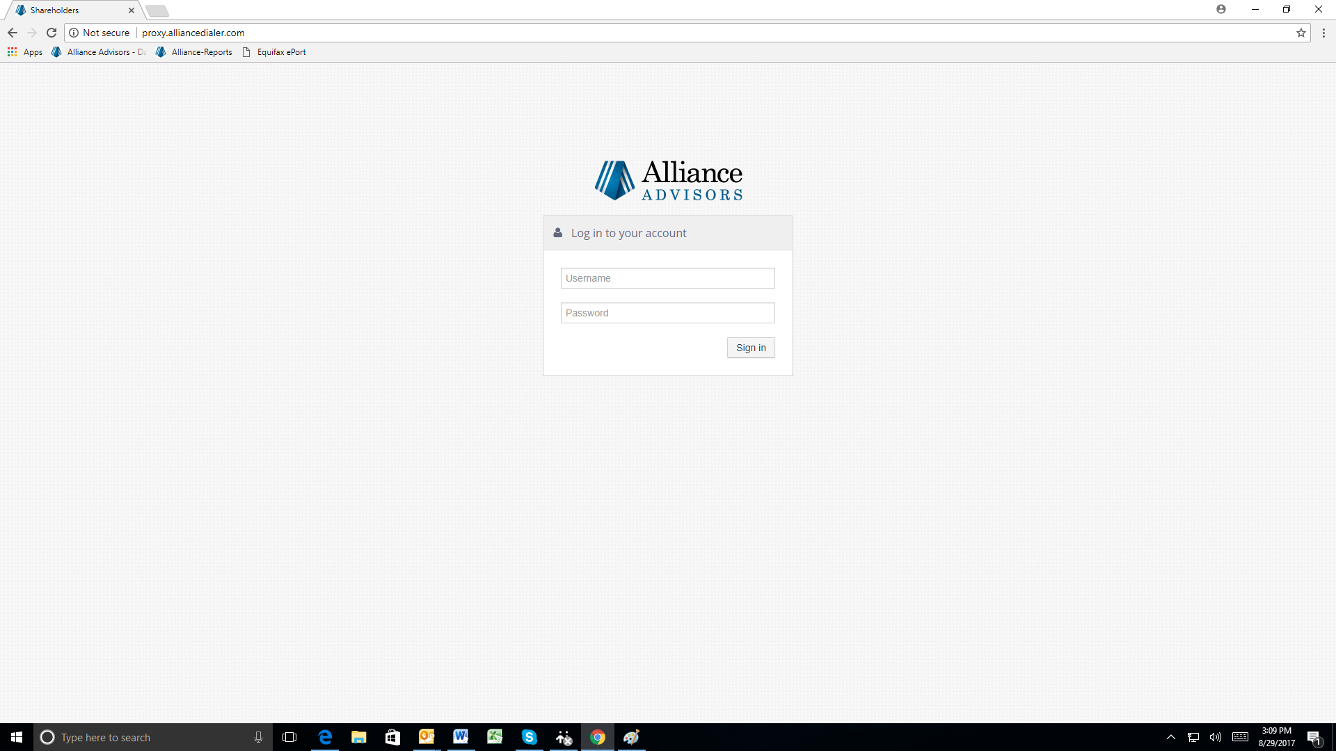

Enter your username and password. Do not change your password.

You will also have to make sure that your Bria is open. The dialing system will not work if you do not have the Bria open. You will be able to find this on the bottom tool bar.

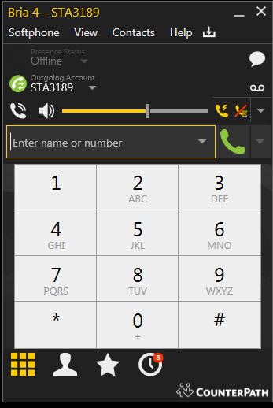

The four digits after STA will be your Bria extension. You will need this when you are signing into the dialer. (For example: the Bria extension here is 3189)

Click on the arrow dropdown to enable:

1. auto-answer.

2. disable call waiting.

**Logging into the Alliance Dialer System**

Once you input your username and password (as displayed on page 12) you will have the ability to pick the job you will be calling (which will be told to you by a team lead) and your Bria extension (as displayed to you on page 13)

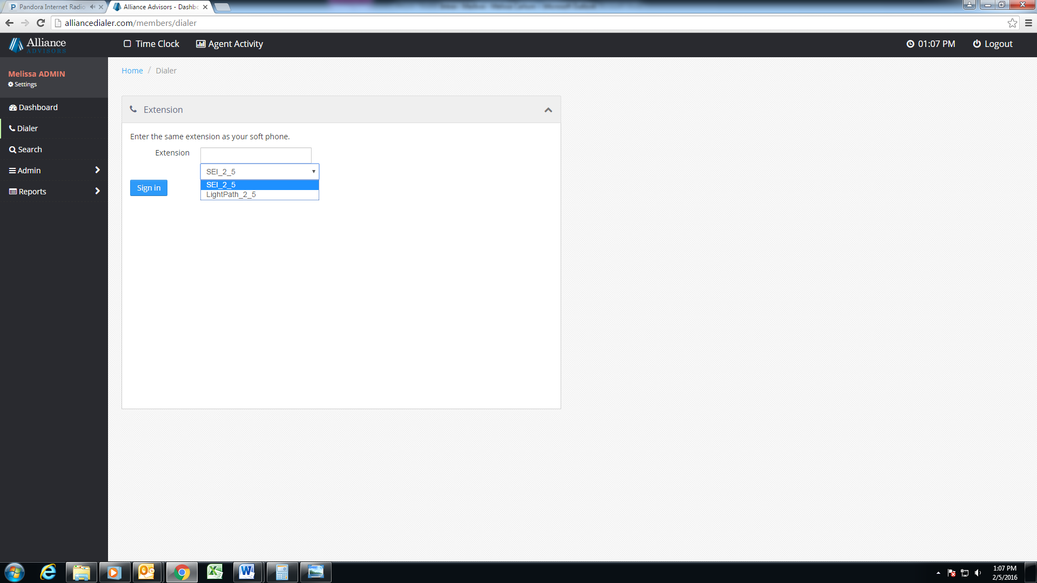

The bottom box is where you will see the drop down of job names. You will choose the job that your team lead assigns you. It is very important that you make sure you choose the correct job.

The top box you will put your Bria extension (as shown on page 13).

**The Account**

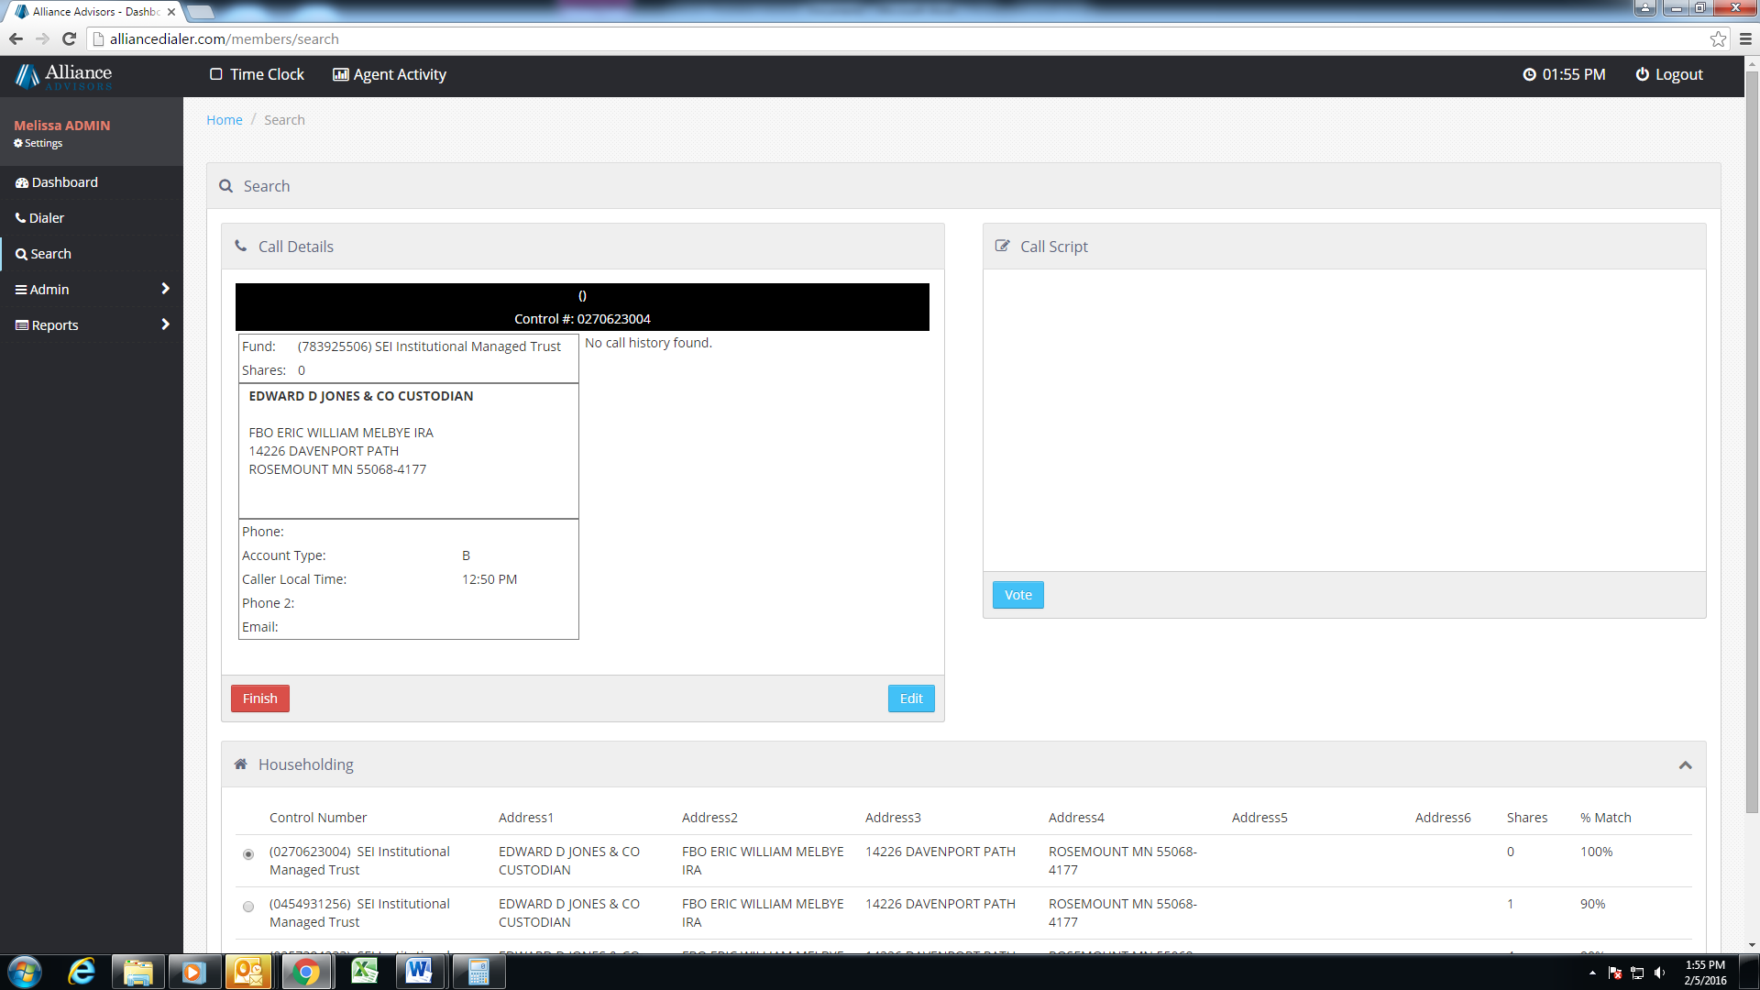

If the shareholder decides not to vote you will hit finish and be able to disposition the call.

If the shareholder decides to vote you will hit the vote button.

You will be asking for Eric William Melbye. Once you confirm that you are speaking to the correct party you will then continue with the script.

**Voting**

You have the option to vote in favor, against, or abstain. If you are voting abstain on a director vote you will have the option of “withhold” as shown below. It is very important that you capture the vote in the manner that the shareholder wishes to vote.

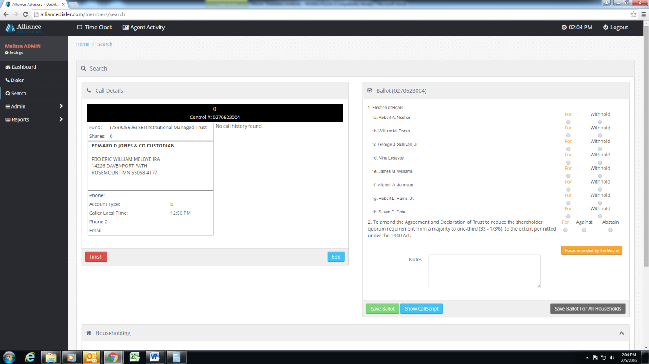

Once all of the accounts are voted you will use this button.

If there are multiple accounts you can use this button.

If the shareholder wants to vote with the Board’s recommendations all you would have to do is hit this button

|  |  |  |
| --- | --- | --- |
|  |  |  |

**Dispositioning**

If you are not voting the account you will have to disposition the account. You will have to choose what disposition best fits what transpired on the call. There will not be a disposition for every scenario. If you are uncertain to which one to use please ask your team lead.

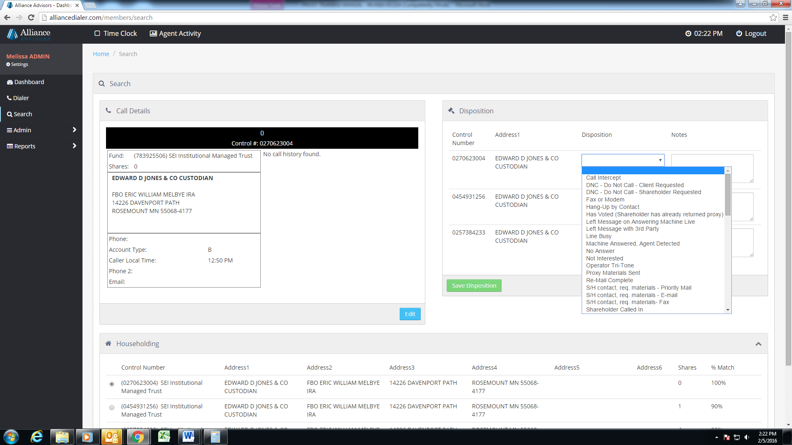

This drop down box will give you all of your disposition options.

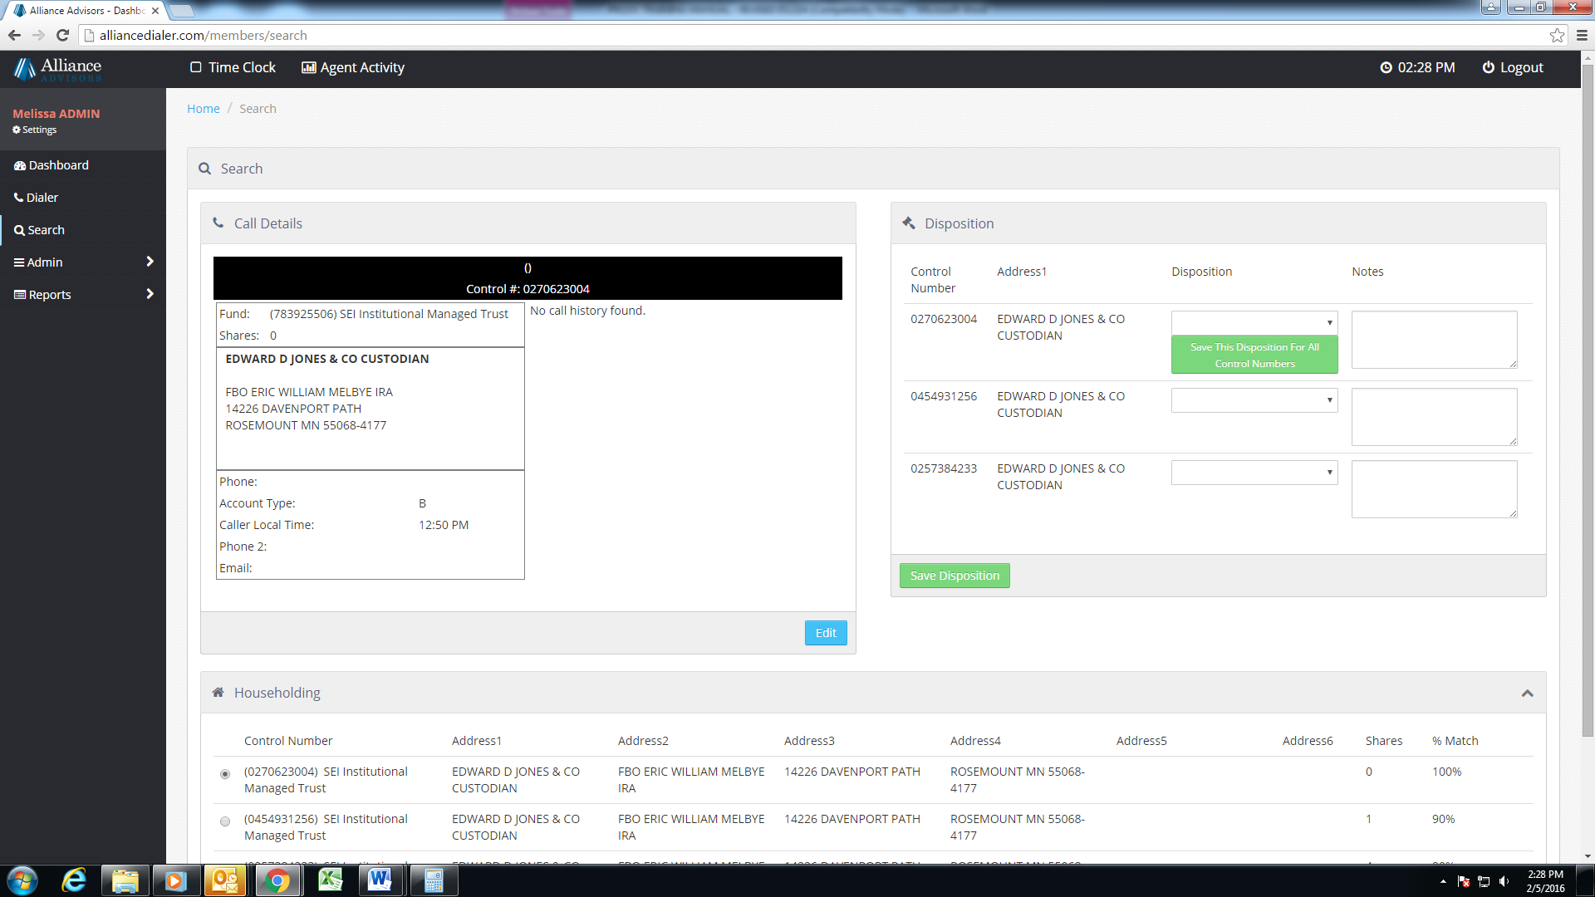

Once you have chosen your disposition and wrote the appropriate notes you will hit this green button and it will save it for all of the accounts.

This box is where you would write detailed notes so that the next agent has an idea of what transpired on the previous call.

**Note:** **When you click finish, you are wrapping up your call and will accumulate a “wrap time.” Keep your time no longer than 30 seconds per call to maintain a low total wrap time for the day. You want to make as many calls as possible to keep your stats high.**

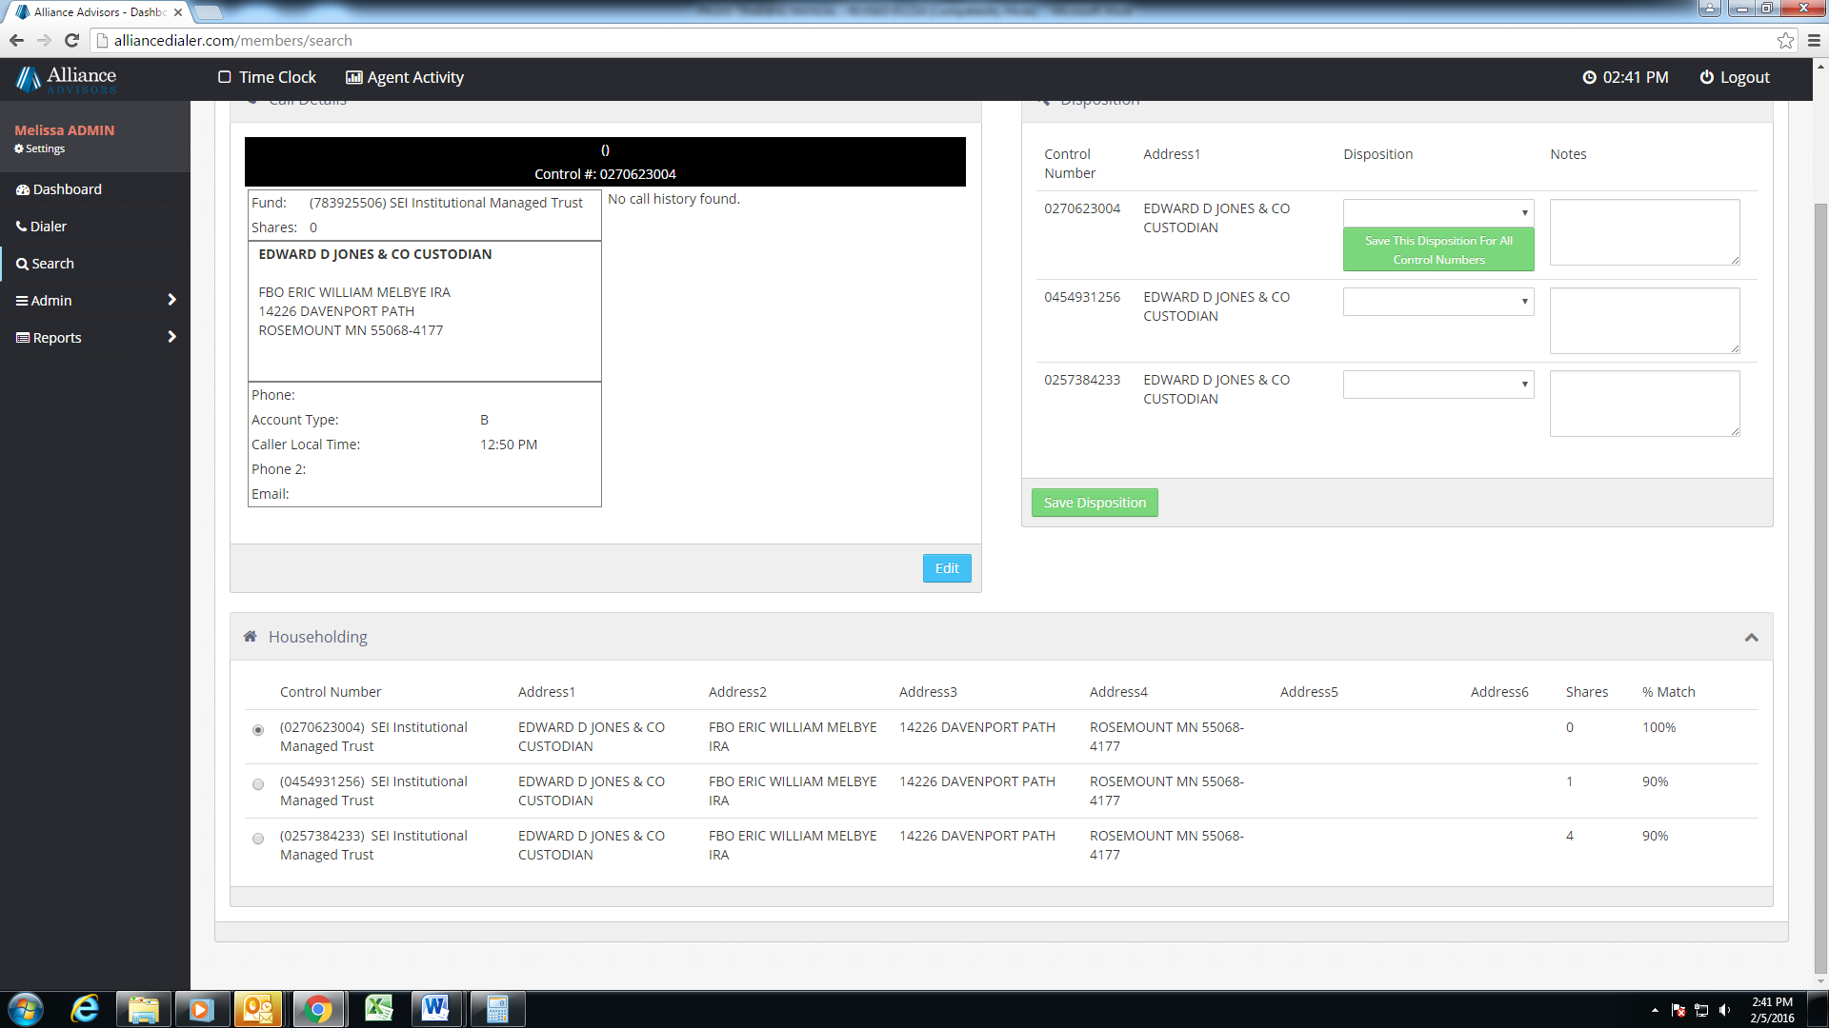

You will use this button when you have to add a new number or an email.

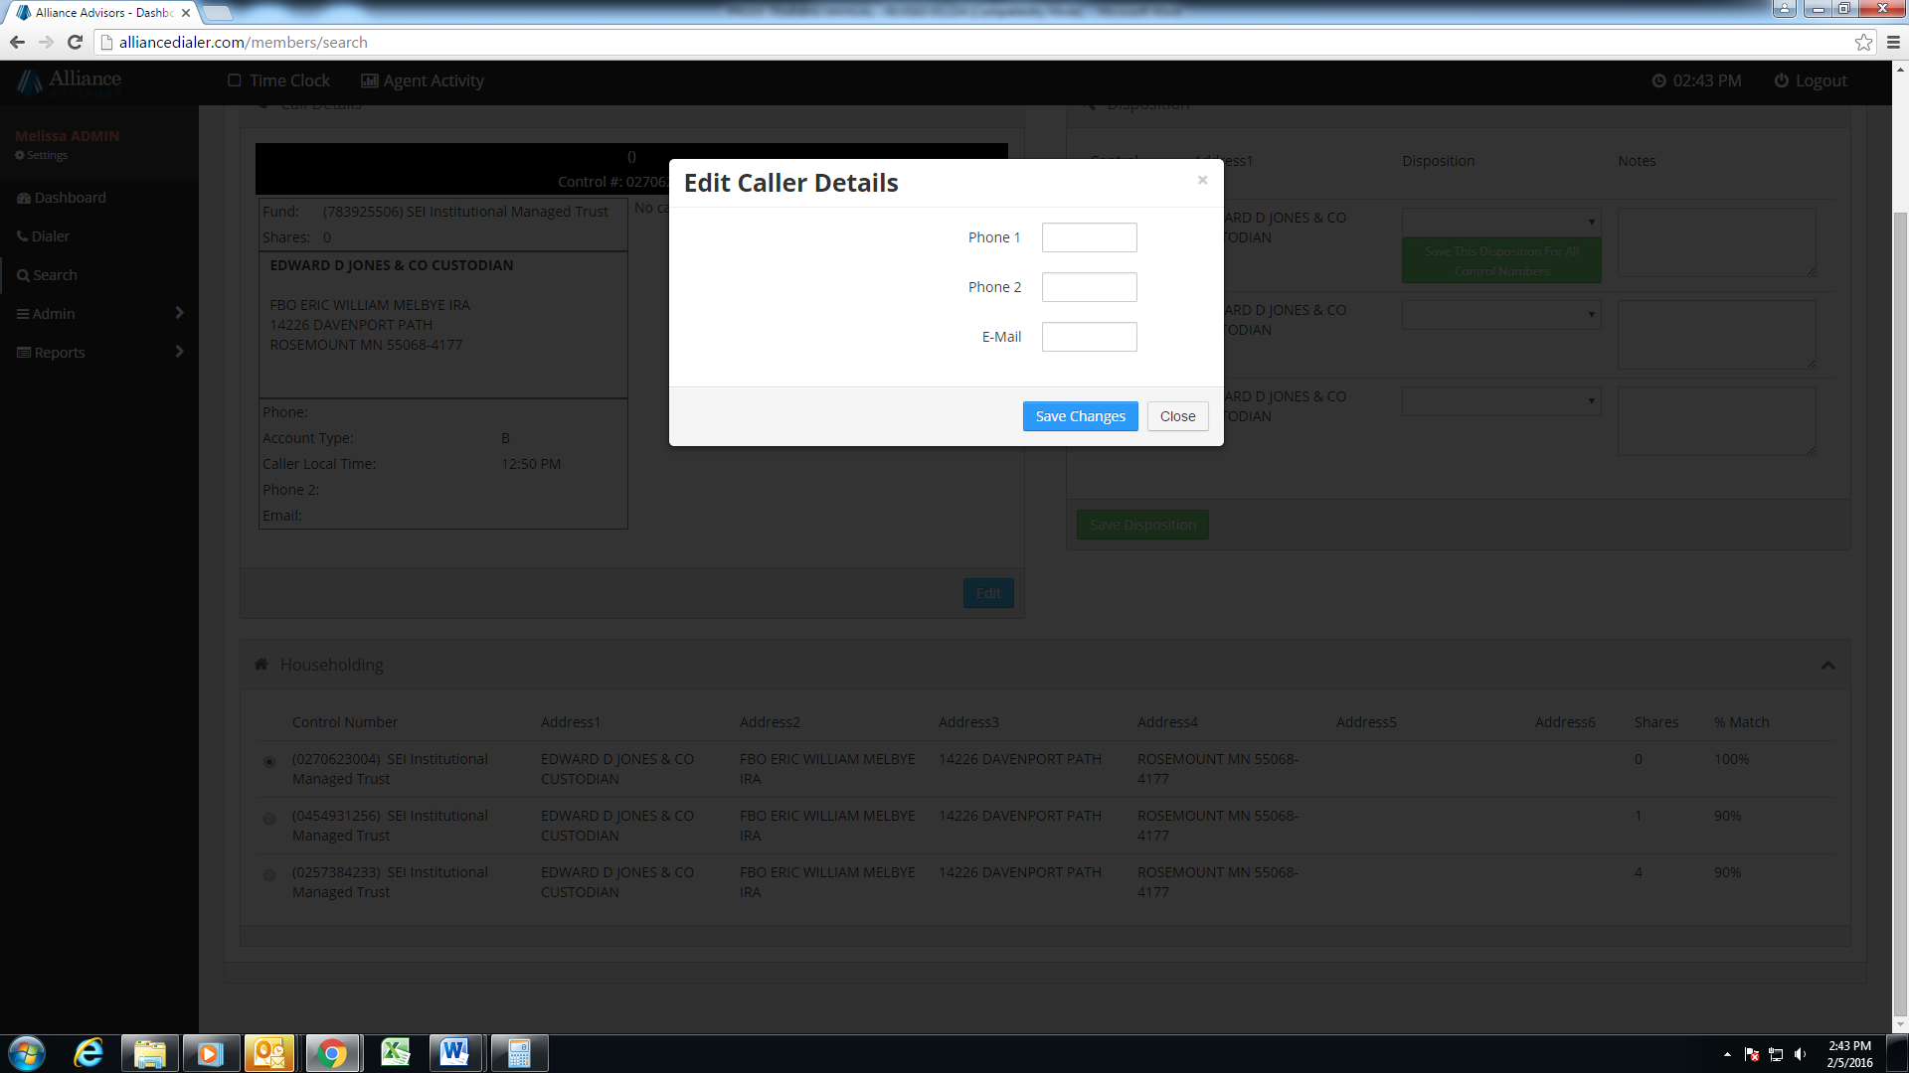

Once you have updated the appropriate information you will hit save changes. Note: Phone 1 is the primary calling number. If you are given a new number to call, the new number goes in phone 1, and the current number goes in phone 2.

This is a sample of what an account would look like with multiple dispositions. When you get the chance, read the notes. You could learn valuable informartion on how to handle the account.

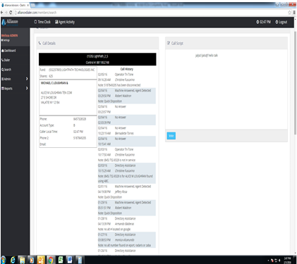

**Logging Out**

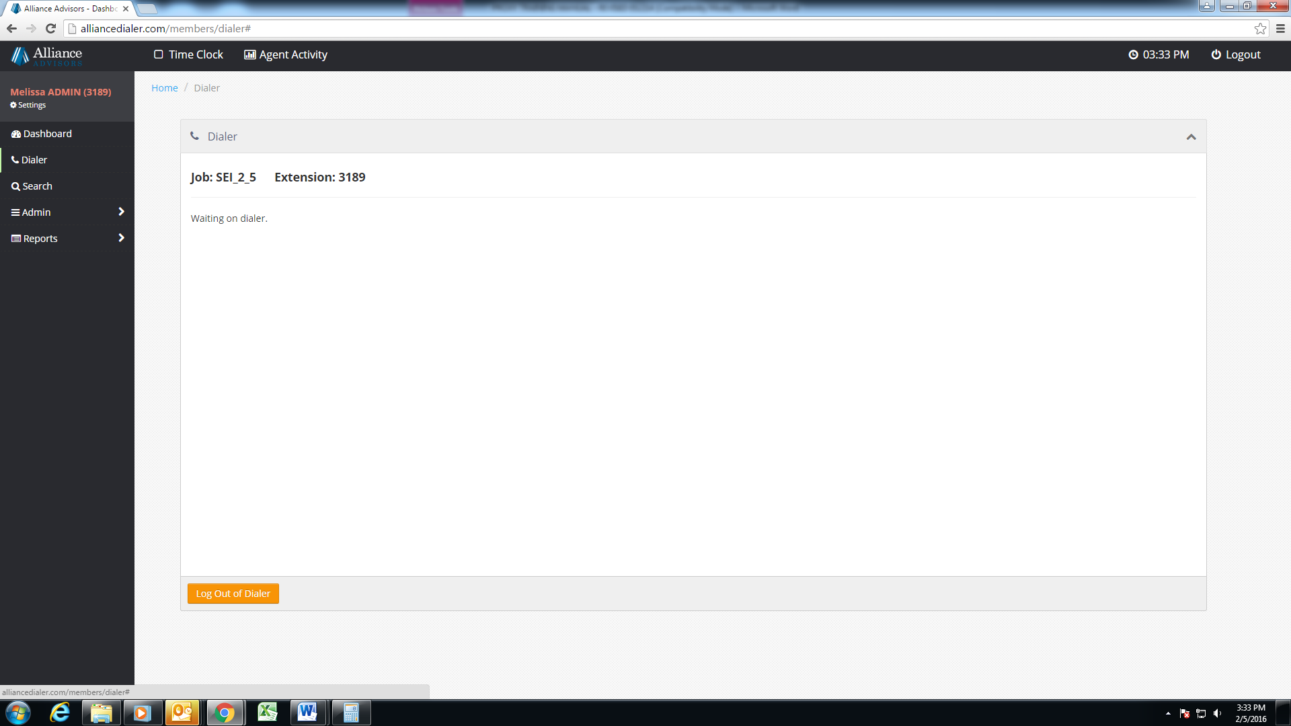

You must hit log out of the dialer to log off or your Bria still will receive calls.

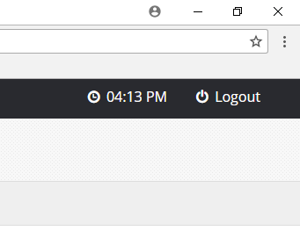

Once you have hit log off of the dialer you must then Log out by hitting this Logout button.

## Clocking in and out

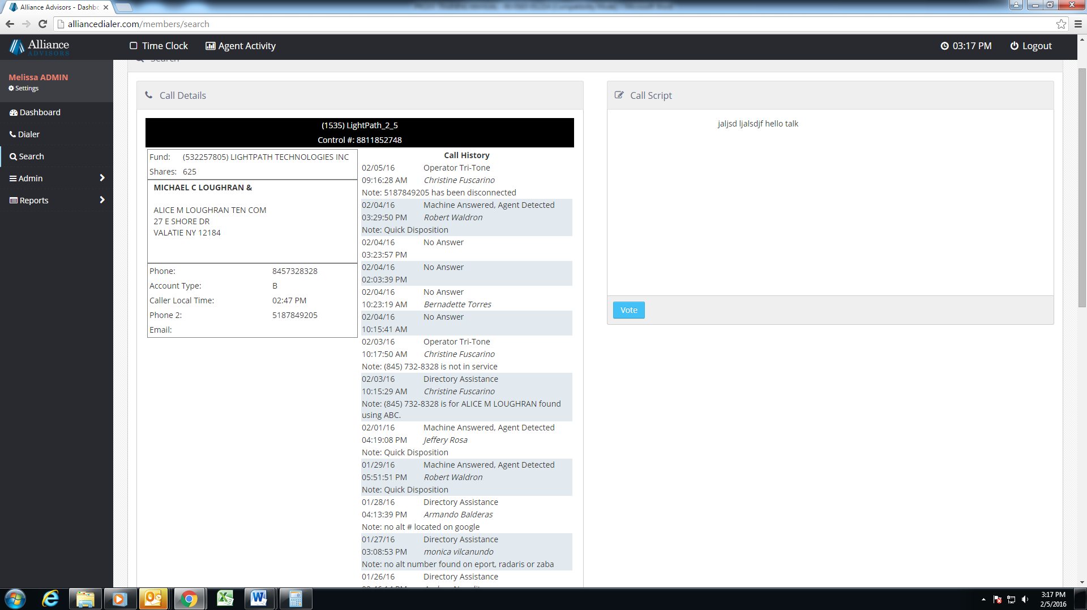

You will clock in and out through the dialer. When you clock in you will hit the time clock. When it is time for you to clock out you will hit the time clock again.

# LIST OF DISPOSITIONS

**CONTACTS:** If we reach a live person who is the proper party. A Contact is a BILLABLE action.

* **ALL ACCOUNTS VOTED** - Votes all accounts in the same manner with the agent on the phone.
* **HAS VOTED** - Already voted or mailed in proxy card, and does not wish to reconfirm their vote.
* **WILL VOTE** - Will vote by mail, internet, or phone later, and does not wish to vote at this time.
* **UNDECIDED (Shareholder not sure)** - Wishes to review the proxy materials before voting.
* **UNDECIDED (Waiting for Advisor…)** - Wishes to consult with a 3rd party before voting.
* **NOT INTERESTED** – Does not wish to vote at the moment or by phone; OR is irate and hangs up.
* **HANG-UP BY CONTACT** - Party answering hangs up BEFORE the fund/job name is identified.
* **LEFT MESSAGE WITH 3RD PARTY** - Agent leaves inbound number with a 3rd party; OR shareholder is not available; OR shareholder wishes to be called later.
* **SH CONTACT, REQ. MATERIALS - E-MAIL** - Requests proxy materials to be E-mailed to them for review before they vote. *\*Update E-mail field.*
* **SH CONTACT, REQ. MATERIALS - PRIORITY MAIL** - Requests proxy materials to be Mailed to them for review before they vote. *\*Confirm the address of record. *Beneficial accounts must call their Brokers to request physical materials.*
* **SHAREHOLDER PLANNING ON ATTENDING MEETING** - States that they plan to attend meeting, so will not vote over phone, and do not need to be called again (considered a DNC).
* **DNC - DO NOT CALL - SHAREHOLDER REQUESTED** - States that they do not want us to call them anymore; OR this call is the forth ‘Not Interested’ and/or ‘Hang Up by contact’.
* **VOTE NOT CONFIRMED BY SHAREHOLDER** – Shareholder was voting but did not complete confirmation. *\*Notify your supervisor, so we can call back the shareholder.*

**NON-CONTACTS:** With the exception of a ‘Wrong Number’* non-contacts are the result of NOT reaching a live person. Non-contacts are not billable.

* **\*WRONG NUMBER** - Party answering states that no one by the name(s) listed in registration resides at the address on record. *\*Use proper wrong number confirmation process by confirming the complete address without stating the street number. *Copy/Paste number into Comments and type in “Wrong Party”. DO NOT DELETE from Phone1.*
* **OPERATOR OR TRI-TONE** - Agent detects recording that the number is “disconnected or no longer in service”. *\*Select/Drag phone number into Comments; label “Disconnected”.*
* **MACHINE ANSWERED, AGENT DETECTED** - Agent detects an answering machine recording, but does not leave a message. *\*Leave message ONLY when instructed.*
* **LEFT MESSAGE ON ANSWERING MACHINE (LIVE)** - Agent leaves a live message on answering machine.*\*Leave message ONLY when instructed.*
* **FAX OR MODEM** - Agent detects a fax or modem signal.
* **CALL INTERCEPT** - Agent not allowed to call-through or leave message due to call blocking service.
* **LINE BUSY** - Agent detects a busy signal.
* **NO ANSWER** - Party does not pick up the phone within four rings.

## Dialer Flow

1. First, make sure to set up VPN, open Bria (turn on: Auto-answer, disable call waiting,) Chatwork, and Team Viewer. Give Teamviewer ID and password to supervisor. Then Log into [proxy.alliancedialer.com](http://proxy.alliancedialer.com).

2. Clock in (select the right supervisor and clock in.)

3. Click on dialer button on alliance dialer, select your Bria extension, and select the right job. Sign in.

4.Wait on dialer. (Calls can come in right away.)

5. When you get a call, try asking for the shareholder.

Conditional Branch

**6a.**If you get a vote, vote the account, click finish, disposition the account.

**6b.**If you do not get a vote, click finish, disposition the account.

Conditional Branch

7.If you need to go on break/lunch/clock out, move to step 9.

Else: go to step 8.

Conditional Branch

8. If your supervisor tells you to switch jobs, log out of dialer, remember the right job, and move to step 3.

Else: Move back to step 4.

Conditional Branch

9a. If you need to go on break: log out of dialer, tell your supervisor via chatwork, click on coffee cup, enjoy your break for 15 minutes, click on coffee cup and move to step 3.

9b. If you need to go on lunch: log out of dialer, tell your supervisor via chatwork, click on time clock, clock out, and enjoy your 30 minute lunch. Then move to step 2.

9c. If you need to clock out for the day, tell your supervisor via chatwork, click on time clock, clock out, and we'll see you tomorrow.

-END-

**Closing**

* Read the script verbatim and use the correct rebuttals. Study and rehearse the script to others. Practice is the only way to get better.
* When confirming a vote, state the **FULL CONFIRMATION**, including the shareholder’s full name and full address on the registration. They can give us more information, but they can’t give us less.
* Show up to work 15 minutes before your shift to be prepared. Keep your break time no longer than 15 minutes, and your lunch no longer than 30 minutes.
* Stay at your seat and do not go to unauthorized websites. If you need to get up from your seat, let your supervisor know.
* Use the right headset which is the Logitech H390. They are good noise canceler and make your voice crisp. Also, be in a quiet environment.
* Work at least 4 hours in a shift. If you can’t work your shift, let your supervisor know.
* If the shareholder has questions about the proxy materials, use your fact sheet to find the answer. If you can’t find the answer, place the shareholder on hold, and ask your supervisor.
* If the person on the phone is irate, remain calm, be polite, and stay professional.

**Good luck being a dialing agent, and if you have additional questions, ask your supervisor. They are here to help you.**

GLOSSARY

**Acquisition**

A **corporate action** in which a company buys most, if not all, of the target company's stakes in order to assume control of the target firm (compare to **Merger**).

**Adjourned**

When a shareholder **meeting** is postponed to a later date due to a lack of **quorum**.

**Annual Meeting**

A mandatory yearly meeting where shareholders are able to gather and ask the **board of directors** questions pertaining to corporate health and strategy, and vote on proposals put forward by the board. Proper notice of meeting times and agenda must be given to shareholders (compare to **Special Meeting**).

**Annual Report**

An annual publication that a **public company** must provide to shareholders to describe their operations and financial conditions. In the case of **mutual funds**, an annual report is a required document that is made available to shareholders on a fiscal year basis.

**Asset**

A resource with economic value that an individual, corporation or government entity owns or controls with the expectation that it will provide future benefit.

**Beneficial Owner**

A shareholder who holds shares through a **custodian**, such as a **broker**, bank or insurance company (see **NOBO** and **OBO**).

**Board of Directors**

A group of individuals elected to be a fair representation of both management and shareholders' interests (**fiduciary** responsibilities) in order to establish policies and make decisions on major company issues, such as the hiring/firing of executives, **corporate actions** and executive compensation. Every **public company** must have a board.

**Bond**

One of the three main **asset** classes, along with **stocks** and **cash equivalents**, where an **investor** loans money to a company or government who borrows the funds for a defined period of time at a fixed interest rate (thus called, “fixed-income securities”) for the purposes of financing special projects or activities.

**Broker**

An individual or firm who acts as the **custodian,** holding assets, for underlying **beneficial** owners (see **NOBO** and **OBO**). Both individuals and firms must be licensed by **FINRA**.

**Capital Gain/Loss**

An increase (gain) or decrease (loss) in the value of a capital **asset** that gives it a higher or lower worth than the original purchase price. A gain/loss is ‘realized’ only after asset is sold.

**Cash and Cash Equivalents**

Items in a **portfolio** that are cash or can be converted into cash immediately (see **Liquidity**). Examples include bank accounts, marketable **securities** and Treasury bills (a type of **bond**).

**Closed-End Fund**

A publicly-traded investment company that raises a fixed amount of capital through an **IPO**. This type of mutual fund is then structured, listed and traded like a stock on a stock exchange (compare to **Open-End Fund**).

**Common Stock**

The most common class of **security** that represents ownership (equity) in a corporation.

**Corporate Actions**

A process that will bring actual change to a company’s stock, such as **stock splits**, **dividends**, **mergers** and **acquisitions**, **rights issues** and **spin offs.** Corporate actions are typically authorized by a vote of the shareholders.

**Corporate Charter**

Also known as "articles of incorporation", is a written document filed with a U.S. state by the founders detailing the major components of their company such as its objectives, its structure and its planned operations. Though details of a charter will vary based on specific regulations and the size of the company, at the most basic level the charter will include the company's name, purpose, number of shares authorized to be issued, and the names of the parties involved.  All changes to the charter must be approved by a vote of shareholders.

**Corporate Governance**

The system of rules, practices and processes by which a company is directed and controlled. Essentially involves balancing the interests of the many stakeholders in a company - these include its shareholders, management, customers, suppliers, financiers, government and the community. It also provides the framework for attaining a company's objectives.

**Costs**

The **management company** of a mutual fund earns their fees from the **investor** in either of two ways: 1) Yearly fees to keep you invested in the fund; 2) Transaction fees (loads) paid each time you buy or sell shares in a fund.

**CUSIP Number**

A unique identification number assigned to all stocks and registered bonds.

**Custodian**

A person or entity (broker, bank, trust company, etc.) responsible for holding financial **assets** for the benefit of an underlying shareholder, or **beneficial owner**.

**Dilution**

A reduction in **earnings** per share of common stock that occurs through the issuance of additional outstanding shares, such as through a **reverse stock split**.

**Diversification**

The idea behind diversification is to invest in a large number of **assets** so that the risk of loss in any particular investment is minimized by gains in others.

**Dividend**

A type of **corporate action** where a distribution of a portion of a company's earnings is authorized by the board of directors to a class of its shareholders. Also, mandatory distributions of income and **capital gains** made to **mutual fund** investors.

**Earnings**

Money made from a **mutual fund** through **capital gains** and dividends on the underlying stocks and bonds, as well as appreciation and interest.

**Economics of Scale**

Because a **mutual fund** buys and sells large amount of **securities** at a time, its transaction **costs** are lower than an individual **investor** would pay.

**Fiduciary**

An individual appointed or elected for their expertise in financial and other matters, who acts in the best interest of another person or organization. A company’s **board of directors**, for example, should act in the best interest of the shareholders, whom they represent. A trustee, custodian, executor, etc., all have fiduciary responsibilities.

**Financial Advisor**

An individual, who for a fee, provides financial advice or guidance to customers such as investment management, income tax preparation and estate planning. They must be licensed by **FINRA**, but are not registered under the Investment Advisors Act of 1940, and do not serve in a fiduciary capacity as **investment advisors** do.

**FINRA - Financial Industry Regulatory Authority**

A self-regulatory body governing business between brokers/dealers and investing public.

**Fundamental Policy**

A policy that must have explicit shareholder approval in order to make any changes (compare to **Non-Fundamental Policy**).

**Holder of Record**

The name of the person who is the registered owner of a **security** and who has the rights, benefits and responsibilities of ownership, such as voting.

**IPO - Initial Public Offering**

The first sale of stock to the public by a **private company**, often seeking capital to expand.

**Investment**

An **asset** purchased with the hope it will generate income or appreciate in value in the future.

**Investment Advisor**

Any person or group registered under the Investment Advisors Act of 1940 who, acting in a fiduciary capacity, makes investment recommendations or conducts securities analysis in return for a fee (compare with **Financial Advisor**).

**Investor**

A person or entity that purchases **assets** with the objective of receiving a financial return. The **portfolio** of an investor commonly includes a balanced variety of assets, such as **securities**, real estate, commodities and collectables for the purposes of **diversification**.

**Issuer**

A company which issues, registers and sells **securities** for the purpose of financing its operations. Whether governments, corporations or investment trusts, issuers are legally responsible for the obligations of the issue and for reporting financial conditions, material developments and any other operational activities as required by regulations.

**Liquidity**

The ability to convert an **asset** to cash; the quicker the conversion, the more ‘liquid’ it is.

**Mail Date**

The date **proxy materials** are sent to the shareholders regarding the upcoming **meeting**.

**Management Company**

The firm that organizes, manages, and administers a **mutual fund**; often called the **Advisor.**

**Merger**

The combining of two or more companies, generally by offering the stockholders of one or both companies **securities** and/or cash in the acquiring or newly-formed company in exchange for the surrender of their stock (compare to **Acquisition**).

**Mutual Fund**

An investment vehicle that is made up of a pool of funds collected from many **investors** for the purpose of investing in **securities**, and operated by a **management company (advisor)**, who invests the fund’s capital and attempts to produce **capital gains** and income for the fund’s investors. A fund’s **portfolio** is structured and maintained to match the investment objectives stated in its **prospectus**. It may be **closed-end** or **open-end**.

**NAV - Net Asset Value**

The per-share value of a **mutual fund**, computed at the end of the day, based on the averaged closing market prices of the underlying **securities** in the fund's **portfolio**.

**Non-Fundamental Policy**

A policy that only requires an approval by the **Board of Directors** in order to make changes, i.e., does not require a vote from the shareholders (compare to **Fundamental Policy**).

**NOBO - Non-Objecting Beneficial Owner**

A **beneficial owner** of a public company who gives permission to release their name and address to a financial intermediary in order to directly receive solicitation, proxy mailings and other shareholder communications. (Alliance can contact these holders directly.)

**OBO - Objecting Beneficial Owner**

A **beneficial owner** of a public company who does not give permission to release their name and address to a financial intermediary in order to directly receive solicitation, proxy mailings and other shareholder communications. (Alliance cannot contact these holders directly.)

**Open-End Fund**

A type of **mutual fund** that does not have restrictions on the amount of shares the fund will issue. If demand is high enough, the fund will continue to issue shares no matter how many investors there are. These funds do not trade on public exchanges, and may buy back shares when investors wish to sell (compare to **Closed-End Fund**).

**OTC - Over-The-Counter Market**

A decentralized market for **securities** not listed on an exchange where market participants trade over the telephone, facsimile or electronic network instead of a physical trading floor. There is no central exchange or meeting place.

**Portfolio**

A grouping of financial **assets** such as stocks, bonds, cash equivalents and **mutual funds**, held directly by **investors** and/or managed by financial professionals, and constructed in accordance with risk tolerance (**diversification**) and investing objectives.

**Preferred Stock**

A class of corporate ownership (equity) with a higher claim on the **assets** and **earnings** than that for **common stock**. It generally has a **dividend** that must be paid out before dividends to common stockholders, but the shares usually do not have voting rights.

**Private Company**

A company whose ownership is strictly private (non-public). As a result, it does not need to meet the strict **SEC** filing requirements of **public companies**. They may issue stock and have shareholders. However, their shares are not issued through an **initial public offering (IPO)** and do not trade on public **securities markets**.

**Prospectus**

A formal legal document required by and filed with the **SEC**, which provides details about an investment offering for sale to the public.  Also called an ‘offer document’, a prospectus should contain the facts that an **investor** needs to make an informed investment decision.

**Proxy Statement**

A document containing the information that a company (**issuer**) is required by the **SEC** to provide to shareholders in order to make informed decisions about matters that will be brought up at a stockholder meeting, such as proposals for new additions to the **board of directors**, information on directors’ salaries or bonus and options plans, and any declarations made by company management.

**Public Company**

A company (**issuer**) that has issued **securities** through an **IPO**, and is traded on at least one stock exchange or in the **OTC** market, and which must meet strict **SEC** filing requirements. Once a company “goes public” it has to answer to all its shareholders (see **Private Company**).

**Quorum**

The minimum acceptable level of shareholders in a company needed to make the proceedings of a meeting valid under the corporate charter. This clause within a company’s charter ensures that there is a sufficient representation of stockholders present at meetings before the **board of directors** can make any changes.

**Record Date**

The ‘cut-off’ date established by the **Issuer** to determine the **holders of record** who can vote.

**Reverse Stock Split**

As opposed to a regular (forward) **stock split**, this **corporate action** reduces the total outstanding shares. It is often initiated for the purposes of increasing the per-share value of the stock. Example: 1-for-5 reverse split consolidates every 5 shares at $1 per share, into 1 share now worth $5). The vast majority of reverse splits are initiated in order to maintain the minimum bid price listing requirements of most exchange markets.

**Routine & Non-Routine Proposals**

A broker is said to have **discretion to vote** a beneficial owner’s shares on **routine** proposals without receiving voting instructions from them.  The broker has no such discretion to vote on **non-routine** proposals.  When **both routine and non-routine** proposals appear on the same ballot and the broker does not receive instructions, a so-called ‘**broker non-vote’** occurs on the non-routine proposal, allowing it to count only for the purposes of **quorum**.

**Security**

A financial instrument issued by a company (**issuer**) that represents some type of financial value and ownership in a **public company** (stock/equity), a creditor relationship with governmental body or corporation (**bond**), or rights to ownership (option).

**SEC - Securities and Exchange Commission**

A government commission created by Congress (the Securities Exchange Act of 1934) designed to regulate the **securities markets,** to promote full public disclosure and to protect the investing public against fraudulent and manipulative practices in the securities markets. It also monitors U.S. corporate takeovers.

**Securities Markets / Stock Exchange**

A place where **securities** are bought and sold—a **stock exchange**—such as the *New York Stock Exchange*, the *Chicago Board of Trade*, *American Stock Exchange*, *NASDAQ*, and **OTC** markets.

**Shareholder / Stockholder**

Any person, company, or other entity that owns at least one share in a company. As owners they have potential to either gain or lose with the company’s performance.

**Special Meeting**

Refers to stockholder meetings held outside of the normal **annual meeting** cycle, primarily driven by special events. For example, **mergers** and **acquisitions**, in which the company being acquired is a **public company**, need to solicit the approval of its stockholders.

**Spin Off**

A type of **corporate action** where the parent company creates a new, independent company through the sale or distribution of new shares of an existing business/division.

**(Forward) Stock Split**

In contrast to a **reverse stock split**, this type of **corporate action** increases the existing company shares by dividing them into multiple shares (e.g., a 2-for-1 split entitles the holder to get 2 shares for every 1 share held). However, the total dollar value remains the same, so a split does not add any real value. A split is usually undertaken to make a very pricey stock more affordable, or to increase the **liquidity** of the stock, which facilitates trading and often results in renewed investor interest, which in turn can positively impact the stock price.

**Sub-advisory Agreement**

A typical fund structure in which a **mutual fund** is managed by a management team or firm other than where the assets are held. Sub-advised funds are often smaller versions of larger mutual funds and hold the same stock proportions as the larger mutual fund. Because there are two management companies being paid, sub-advised funds can often have layered fees.

**Ticker Symbol**

An arrangement of characters representing a particular **security** listed on a stock exchange.

**Transfer Agent**

A trust company, bank or similar financial institution assigned by a corporation as its ‘registrar’, to maintain records, account balances and transactions of its **investors**.

